BELMONT CITY COLLEGE

YEAR 11 ATAR MODERN HISTORY
SOURCE ANALYSIS – UNIT 1
SEMESTER ONE 2015

DOCUMENT BOOKLET

MODERN HISTORY – TASK ONE

SOURCE ANALYSIS

Date: Week 3, Semester One 2015
Marks: 25 marks
12.5% of Semester Total

CONTENTS:

Document Set | Area of Study | Number of sources | Related questions
1 | Elective 5: The Age of Imperialism | 4 | 1 (5 parts)

DOCUMENT SET - THE AGE OF IMPERIALISM

Source 1
Extract from a speech by Jules Ferry, the Premier of France, 1883-85.

BACKGROUND INFO (THIS IS NOT THE SOURCE):
After the military defeat of France by Prussia in 1870, Ferry formed the idea of acquiring a great colonial empire, principally for the sake of economic exploitation. Ferry directed the negotiations which led to the establishment of a French protectorate in Tunis (1881), prepared the treaty of 17 December 1885 for the occupation of Madagascar; directed the exploration of the Congo and of the Niger region; and above all, he organised the conquest of Annam and Tonkin in what became Indochina (Vietnam).

“Gentlemen, we must speak more loudly and more honestly! We must say openly that indeed the higher races have a right over the lower races. . . . I repeat, that the superior races have a right because they have a duty. They have the duty to civilize the inferior races. . . . In the history of earlier centuries these duties, gentlemen, have often been misunderstood; and certainly when the Spanish soldiers and explorers introduced slavery into Central America, they did not fulfil their duty as men of a higher race. . . . But, in our time, I maintain that European nations acquit themselves with generosity, with grandeur, and with sincerity of this superior civilizing duty.”

From Jules François Camille Ferry, "Speech Before the French Chamber of Deputies, March 28, 1884," Discours et Opinions de Jules Ferry, ed. Paul Robiquet (Paris: Armand Colin & Cie., 1897), -1. 5, pp. 199-201, 210-11, 215-18. Translated by Ruth Kleinman in Brooklyn College Core Four Sourcebook

Source 2
This excerpt was written by American Senator A.J. Beveridge in 1898.

BACKGROUND INFO (THIS IS NOT THE SOURCE): Beveridge is known as one of the great American imperialists. He supported the annexation of the Philippines and along with Republican leader Henry Cabot Lodge he campaigned for the construction of a new navy.

“American factories are making more than the American people can use; American soil is producing more than they can consume. Fate has written our policy for us; the trade of the world must and shall be ours....We will establish trading posts throughout the world as distribution points for American products. We will cover the ocean with our merchant marines. We will build a navy to the measure of our greatness..

SEE NEXT PAGE

Source 3
"The World's Plunderers" was created by Thomas Nast and appeared in Harper's Weekly in 1885.

BACKGROUND INFO (THIS IS NOT THE SOURCE): Harper's Weekly (A Journal of Civilization) was an American political magazine based in New York. Published by Harper & Brothers from 1857 until 1916, it featured foreign and domestic news, fiction, essays on many subjects, and humour, alongside illustrations. During its most influential period, it was the forum of the political cartoonist Thomas Nast.

"The World's Plunderers" was created by Thomas Nast and appeared in Harper's Weekly in 1885. In the image, Germany, Britain and Russia are carving up the world with their imperialistic desires. They are each carrying a bag with which they can gather their new holdings in. Asia and Africa are the main countries that appear on the globe because they were the main areas divided up during the period of new imperialism. India is separately marked as it is observed by the British because it was the “jewel” the Britain’s colonial empire. Nast situates Europe at the top of this world, displaying the European power as it overlooks its foreign possessions. Nast is ultimately opposed to imperialism, and he makes this known through his title. He uses the word “plunderers” to describe Germany, Britain and Russia making them sound like thieves taking what is not rightfully theirs. Nast uses the words “grab bags” to describe what the countries were holding because the word implies taking something forcefully and without permission.

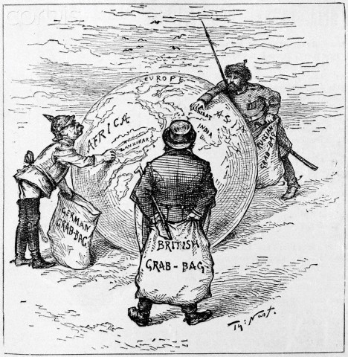

SEE NEXT PAGE

Source 4
'The Devilfish in Egyptian Waters.' An American cartoon from 1882 depicting John Bull (England) as the octopus of imperialism grabbing land on every continent.

BACKGROUND INFO (THIS IS NOT THE SOURCE): John Bull is not a real person, it is a name that was used to represent England; much like Uncle Sam represents the United States. Max O’Rell was a French author/journalist who states that: John Bull is a large landowner. His estate, to which he adds a piece day by day, consists in the first place of the British Isles, to which he gave the name of the United Kingdom. Then he has the Channel Islands, and the fortress of Gibraltar, (Gibraltar is a very strategic piece of land at the bottom of Spain and which sits at the entrance to the Mediterranean Sea – between Europe and North Africa) which enables him to pass comfortably through the narrowest of straits. The islands of Malta and Cyprus serve him as advanced sentinels (lookouts/guards) in the Mediterranean. If he could have Constantinople he would be satisfied with his share of Europe. In Egypt he is not quite comfortable; yet he is trying to make himself at home there. He took good care not to invent the Suez Canal, (the French did) and moved heaven and earth to try and prevent the canal from being made; yet behold him to-day, as a major shareholder. He occupies his territory with an army considerably inferior in numbers to that of any other continental Power, in spite of which none of his possessions is in the least danger […] The French fight for glory, the Germans for a living, the Russians to divert attention of the people at home from home affairs. But John Bull is a reasonable, moral, and regenerating character. He fights to promote trade, to maintain peace and order on the face of the earth, and for the good of humankind in general. If he conquers a nation it is to improve its condition in this world, and secure its future in the next. He is a curious mixture of the lion, mule, and octopus.

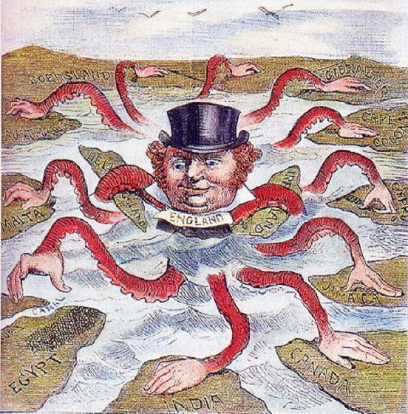

Note: The countries referred to include (from left to right): Boersland, Gibraltar, Australia, Cape Colony, Malta, Heligoland, Ireland, Cyprus, Suez Canal, Egypt, India, Jamaica, and Canada.
ACKNOWLEDGEMENTS

Document Set

Source 1 Jules François Camille Ferry, 1884, "Speech Before the French Chamber of Deputies, March 28, 1884," Discours et Opinions de Jules Ferry, ed. Paul Robiquet (Paris: Armand Colin & Cie., 1897), -1. 5, pp. 199-201, 210-11, 215-18. Retrieved from: https://ims.ode.state.oh.us/ODE/IMS/Lessons/Content/CSS_LP_S01_BC_L09_I05_01.pdf

Source 2 A.J. Beveridge, 1898, Retrieved from:
http://www.worldhistory10.com/uploads/7/4/6/7/7467507/u9-imperialismcausesquotes.pdf

Source 3 N. Thomas, 1885, "The World's Plunderers", Harpers Weekly. Retrieved from:
http://dconfairch22.blogspot.com.au/2012/03/imperialism.html

Source 4 Unknown author, 1882, “The Devilfish in Egyptian Waters.” Retrieved from:
http://www.granger.com/results.asp?inline=true&image=0056521&wwwflag=4&itemx=18&screenwidth=1280

